Instructions to Submit Comments
- Go to regulations.gov
- Search for “Inadmissibility on Public Charge Grounds” or “RIN: 1615-AA22”
- Click on “Comment Now”

- Upload the comment 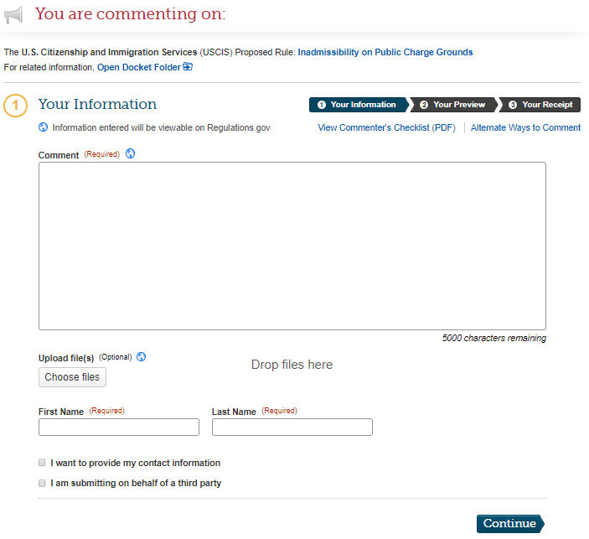
- Follow instructions to complete submission

[Date]
Submitted via regulations.gov
U.S. Citizenship and Immigration Services
Department of Homeland Security
20 Massachusetts Ave. NW
Washington, DC 20529-2140

RE: DHS Docket No. USCIS-2010-0012, RIN 1615-AA22; Notice of Proposed Rulemaking – Inadmissability on Public Charge Grounds
To Whom It May Concern:
[Organization or individual name] submits these comments to express our strong opposition to the Department of Homeland Security’s (DHS) Notice of Proposed Rulemaking (NPRM or proposed rule) on Inadmissibility on Public Charge Grounds.
[Two to three sentences about your organization or your interest as an individual] Farmworkers are an essential part of our economy, our food and agriculture systems, and our communities. [Add anecdote or data from your community to illustrate farmworkers’ positive contributions] The large majority of farmworkers are immigrants. As we detail in our comments, the proposed rule would hurt farmworkers, their families, and the communities in which they live as well as harm an essential economic sector. For the reasons discussed below, we urge DHS to withdraw this rule in its entirety.
- The proposed rule’s criteria for the factors to be considered in the “totality of circumstances” test disadvantage farmworkers
The proposed rule defines and attributes negative and positive values to the various factors to be considered in a person’s totality of circumstances in the context of applications for immigrant and non-immigrant status. These definitions and values will disadvantage many farmworkers who seek to either apply to adjust to Lawful Permanent Resident (LPR) status or apply for or extend their nonimmigrant H-2A status. The proposal would unreasonably and arbitrarily deprive many farmworkers and family members the opportunity to come to the United States, extend their work status, or live permanently in the United States.
- Income and household size
The proposed rule harms farmworkers by penalizing low incomes; income below 125% of Federal Poverty Level (FPL) is considered a negative factor in the balancing test for determining public charge. According to the Department of Labor’s National Agricultural Workers Survey (NAWS), the average total individual income of farmworkers range from $15,000 to $17,499.
An estimated 30% of farmworkers have a family income below 100% FPL. Many farmworkers are supporting family members in the U.S. The average farmworker household has two minor children, many of whom may be U.S. citizens. When taking into account other household members, including children and relatives abroad, the household incomes of farmworker families are often far below 125% of the FPL.
Farm laborers’ wages are among the lowest in the nation through no fault of their own. A large share of farm jobs is seasonal by nature, which means that periods of unemployment are inherent in this vital occupation and farmworkers’ incomes fluctuate during the year. The hourly wages of many farmworkers are often at or near the minimum wage. Yet under federal and most state laws, small farmers are not obligated to pay the federal minimum wage of $7.25 per hour or the state minimum wage. Farmworkers also generally work long hours, but are excluded from the right to time-and-one-half pay after 40 hours of work.
[Add data about farmworker wages in your area]
For individuals below 125% FPL, the proposed rule requires that they demonstrate that their assets are equal to five (5) times the difference between their FPL and 125% FPL. Evidence for such assets includes additional income from other household members, checking and savings accounts, and other non-cash assets. An individual’s credit score, credit history, and debt will also be considered to assess financial status. Few farmworkers and their family members will be able to overcome the proposed rule’s many barriers to demonstrating sufficient assets and incomes. The NPRM would unreasonably and arbitrarily deprive many farmworkers and their family members the opportunity for immigration status.
- Education and English Language Skills
The proposed rule implies that only highly educated, highly proficient/fluent English speakers are able to obtain employment in the U.S. and deserve access to immigration status. DHS proposes to assess whether an individual has at least a high school or equivalent degree and is proficient in English as part of the public charge determination. Farmworkers often have limited formal education and English proficiency. Many workers have at or below an 8th grade education. Fifty-nine percent of farmworkers report that they speak little or no English.
Yet agricultural work, although considered unskilled labor under some technical definitions, is in fact a skilled occupation requiring knowledge, precision, exercise of judgement, endurance, and speed. In fact, the majority of farmworkers have spent many years in agriculture, an average of 16 years, acquiring the necessary skills to be successful in their work and contributors to their employers’ profitability and therefore essential to our highly efficient agricultural system. Many H-2A workers have been working in U.S. agriculture for many years, returning year after year at the invitation of the same employer based on their experience and skill. [Add any additional information about H-2A workers in your area if you have it] The proposed rule’s provisions on education and English-language skills would improperly reject the value of many farmworkers’ contributions to our economy and society.
- Health Insurance
The proposed rule will consider the lack of private health insurance or financial resources to pay for medical costs as a heavily weighed negative factor if an individual has a medical condition that may interfere with their ability to work. Immigration status should not be denied to farmworkers because of agricultural employers’ refusal or economic inability to provide health insurance or the low wages that make health insurance unaffordable. Despite the many health risks associated with agricultural work, the majority of farmworkers (65%) lack health insurance of any kind. Seventy-eight percent of workers reported that their employer did not provide health insurance or pay for medical treatment for injuries or illnesses suffered outside of work. Only 14% of agricultural employers offer health insurance to their workers. [Add any data or anecdotes about employer-provided health insurance in your area]
Few farmworkers can afford private health insurance, even if offered by their employer. Those employers who offer health insurance often require a financial contribution by the worker, which may be an unaffordable amount. [Share some specific information about the cost of private health insurance, if available] H-2A workers are covered by workers’ compensation insurance for any work-related injuries or illnesses but few have access to comprehensive health insurance. There is evidence that workers who acquire immigration status and citizenship and settle in communities rather than continuing to migrate are likely to obtain health insurance, which is a reason to reject this proposal’s restrictions on access to immigration status.
- The proposed rule falsely equates low-wage work with lack of self-sufficiency
The realities of the private marketplace in America’s economic system mean that millions of hard-working, productive people earn low wages. An estimated 41.7 million people earn under $12 an hour. The proposed rule falsely assigns immigrants to two groups – those who are dependent on benefits and those who are independent workers. The reality of low-wage work, especially in the agricultural industry, is that workers may diligently pursue employment, work hard for long hours, and still earn low incomes and be in need of additional supports. Farmworkers especially face a wide range of challenges to making a living and supporting their families through no fault of their own. [Add anecdote about challenges faced by farmworkers in their communities]
Congress and the American people have recognized that some self-sufficient people in this society should be provided access to certain public benefits to ensure a vibrant economy and meet basic human needs of the workforce. Enrollment in programs such as Medicaid and SNAP has made our farmworker families and communities healthier, helping sustain our nation’s prosperity. [Add a few sentences with an anecdote about how enrollment in programs like Medicaid and SNAP have helped farmworker families and the value these farmworkers bring to the community]
Few farmworkers are enrolled in public benefit programs such as Medicaid and SNAP for which they may be eligible. Only 37% of insured workers received health insurance through Medicaid. Children, however, are, appropriately, likely to be enrolled in Medicaid. Eighty-two percent of farmworker children receive their health insurance through Medicaid. SNAP participation among farmworker families has historically been low. According to the NAWS, only 16% of workers reported that they or someone in their household received SNAP in the previous two years.
- The proposed rule will result in a chilling effect, discouraging enrollment in programs and utilization of health services by farmworkers and their family members
The proposed rule, if finalized, would create an unfair and dangerous chilling effect: out of fear that they or their family members would be denied the ability to become an LPR or to renew a nonimmigrant visa, many individuals will be afraid to access programs for which they or their family members are eligible. Farmworkers already have low participation in public benefits programs. Therefore farmworker children, with their high participation rate in government programs, will be the most harmed by the proposed rule.
Reports from the ground indicate that many farmworker families are already disenrolling from various programs and foregoing vital health services, jeopardizing the heath of their families and communities alike. [Add anecdote about the chilling effect you are seeing in your community]
Yet enrollment in programs such as SNAP and Medicaid ensures that farmworker families are healthy through access to food and preventative health care. The value of access to public benefits is well documented. Multiple studies confirm that early childhood or prenatal access to Medicaid and SNAP improves health and reduces reliance on cash assistance. [Add anecdote about benefit of access to program such as Medicaid and SNAP for the workers and families in your community]
- The proposed rule’s requirement to include a public charge assessment of non-immigrant visa holders who are extending their visa is unnecessary and could further isolate H-2A workers
Under the proposed rule, USCIS must conduct a public charge assessment of individuals requesting to extend or change their nonimmigrant status. Not only is this assessment unnecessary but will also create delays that negatively impact workers who hold visas under the H-2A temporary foreign agricultural worker program.
The impact on H-2A workers is increasingly important because the program is growing rapidly, from 200,049 positions certified by the U.S. Department of Labor in 2017 to over 242,000 in 2018. Before receiving their visas, H-2A workers undergo a public charge assessment at the Consular offices in their home countries. Once in the U.S., H-2A workers are not eligible for the vast majority of public benefits, including TANF, Medicaid, or SNAP. Moreover, they are provided housing by their employer, so they would not seek rental assistance.
It is unnecessary to provide an additional public charge assessment for individuals seeking an extension of their visas. H-2A workers are already reluctant to seek services once in the U.S. due to fear of employer retaliation. Confusion regarding public charge could create a chilling effect among H-2A workers, further isolating them from the communities where they work and live. Moreover, H-2A workers facing delays and uncertainty in the extension of their visa status may become more vulnerable to recruitment fees and agent costs which, while prohibited, are a common abuse in a program set up to take advantage of economically vulnerable workers. [Add anecdote about chilling effect among H-2A workers to access community services either due to confusion about public charge and/or fear due to potential employer retaliation] The additional assessment will not only create delays for employers who seek to extend their H-2A workers’ visas but will also discourage workers from seeking any community services due to fear about the impact it may have on their visa.
In conclusion, [organization name or if an individual, “I” or “the undersigned individuals”] strongly oppose the proposed rule on public charge. The rule is inconsistent with the history of how public charge has been understood and applied and would make arbitrary and capricious changes. Farmworkers are not only vital to our economy and food security; they are also vital to our communities. Yet under this proposed rule, many farmworkers, domestic and H-2A workers, could find themselves determined a public charge due to factors beyond their control such as low wages, poverty-level income, and a lack of health insurance. Our country must continue to value the contributions of low-wage workers, including farmworkers, and recognize that value in the context of our immigration system. It is therefore vital that this rule is not finalized.
Sincerely,
[Name]
[Organization]

U.S. Department of Labor, Findings from the National Agricultural Workers Survey 2013-2014 (NAWS), published Dec. 2016, available at https://www.doleta.gov/agworker/pdf/NAWS_Research_Report_12_Final_508_Compliant.pdf., p. iii
NAWS, p. iii
NAWS, p. 8
29 U.S.C. § 213(b)(12) (2012 & Supp. II 2014)
NAWS, p. 10
NAWS, p. 13
NAWS, p. 29
NAWS, p. 41
NAWS, p. 24
NAWS, p. 24
NAWS, p. 41
Oxfam, Millions of low-wage workers in the U.S. are struggling to survive, published June 21, 2016, available at https://www.oxfamamerica.org/explore/stories/millions-of-low-wage-workers-in-the-us-are-struggling-to-survive/
NAWS, p. 42
NAWS, p. 43
NAWS, p. 40
Office of Foreign Labor Certification, U.S. Department of Labor, 2017 H-2A Annual Performance Report – Selected Statistics, available at https://www.foreignlaborcert.doleta.gov/pdf/PerformanceData/2017/H-2A_Selected_Statistics_FY2017.pdf.
Office of Foreign Labor Certification, U.S. Department of Labor, 2017 H-2A Annual Performance Report – Selected Statistics, available at https://www.foreignlaborcert.doleta.gov/pdf/PerformanceData/2017/H-2A_Selected_Statistics_FY2018.pdf.

